- Directions: Fill in the blanks with the correct words.
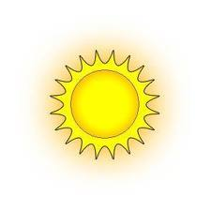__________ Reactions

____________

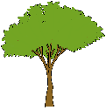 in ______________, _______________, and __________________

The sun excites e⁻ from _______________.
e⁻ = ____________

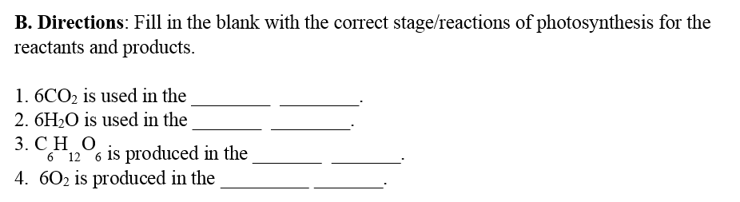

e⁻ goes down the 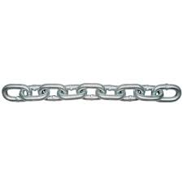___________ ________ _____

creates

___________ _______ and ________
Released

_________________

_____________ + ________________from the light reactions with _____

Goes around _____X (times) to make….

_________________

