Name:

Date:

Class:

**Glycolysis, Fermentation, & Cellular Respiration**

Released

Made

Made

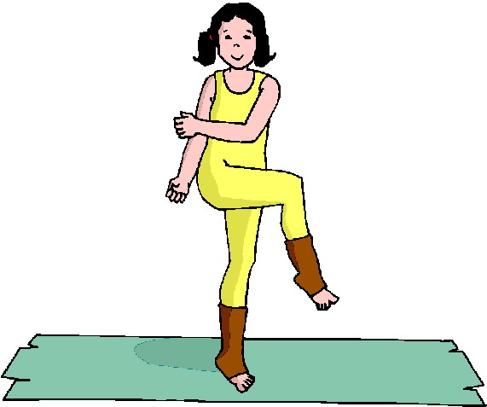

in

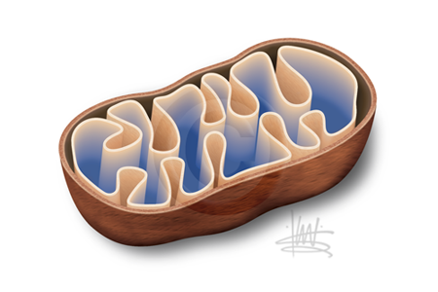

in the

With Oxygen ( )

Called

ATP

ATP

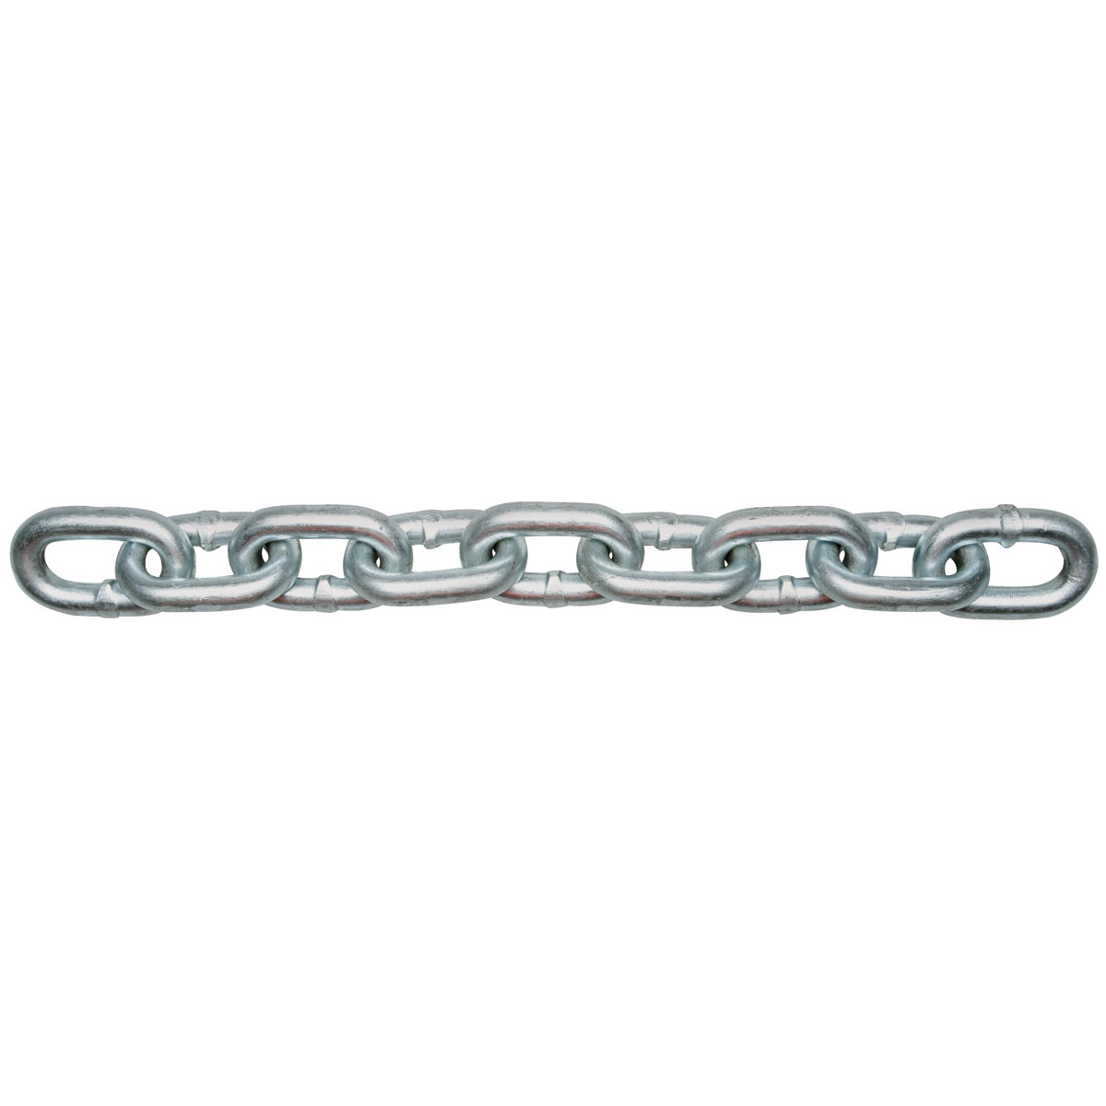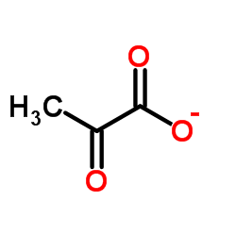

Makes…



Animals ATP

Released

in

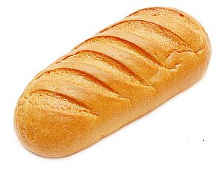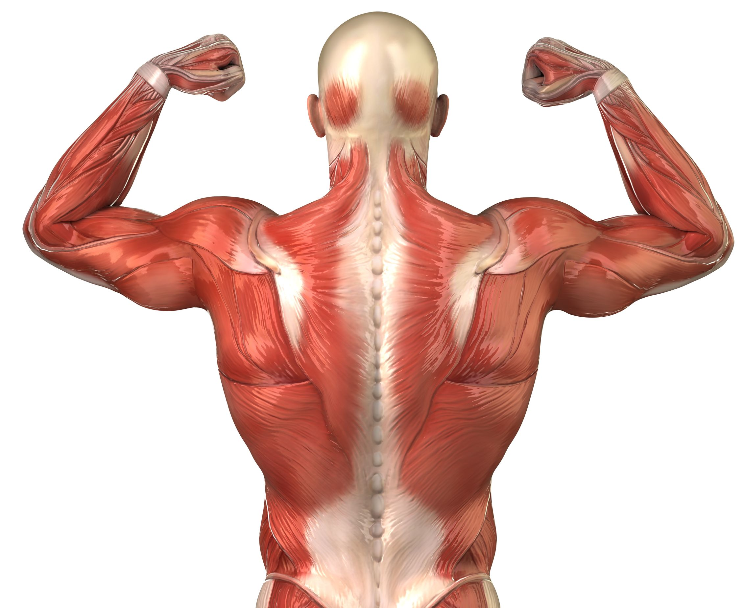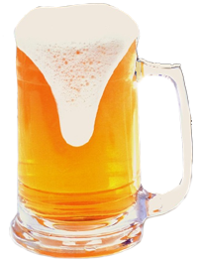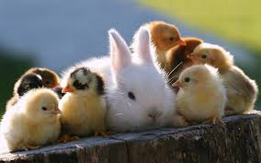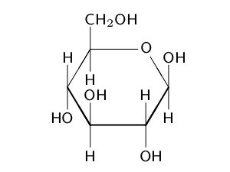

ATP

Yeasts

And

Some Plants

in

is used in the

Without Oxygen

( )

Called 

________ Total ATP

is made

Part B: Fill in the blank to indicate which process each is used or produced in.

1. C6H12O6 is used for ______________________.
2. O2 is used in the ___________________.
3. H2O is produced in the ___________________.
4. CO2 is produced in the ___________________.