Evidence of Evolution
Background
When Charles Darwin first proposed the idea that all new species descend from an ancestor, he performed an exhaustive amount of research to provide as much evidence as possible. Today, the major pieces of evidence for this theory can be broken down into the fossil record, embryology, comparative anatomy, and molecular biology.

Fossils
This is a series of skulls and front leg fossils of organisms believed to be ancestors of the modern-day horse.

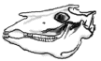 | 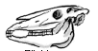 | 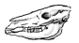
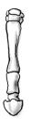

Equus  (modern horse) | Pilohippus | Merychippus | Mesohippus | Eohippus  (Dawn Horse)
Source: http://www.iq.poquoson.org
1. Give two similarities between each of the skulls that might lead to the conclusion that these are all related species.

2. What is the biggest change in skull anatomy that occurred from the dawn horse to the modern horse?

3. What is the biggest change in leg anatomy that occurred from the dawn horse to the modern horse?

Embryology
Organisms that are closely related may also have physical similarities before they are even born! Take a look at the six different embryos below:
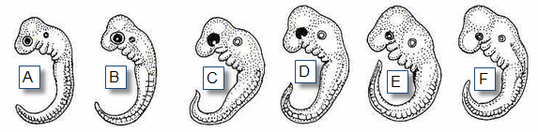
Source: http://www.starlarvae.org

Hypothesize which embryo is from each of the following organisms:

Species | Embryo
Human
Chicken
Rabbit
Tortoise
Salamander
Fish

These are older, more developed embryos from the same organisms.
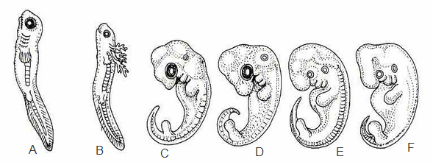
Hypothesize which embryo is from each of the following organisms:

Species | Embryo
Human
Chicken
Rabbit
Tortoise
Salamander
Fish

These are embryos at their most advanced stage, shortly before birth.
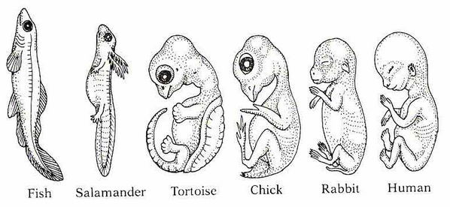
Describe how the embryos changed for each of these organisms from their earliest to latest stages.

Species | Anatomical Changes From Early to Late Stages
Human
Chicken
Rabbit
Tortoise
Salamander
Fish

1. Look again at the six embryos in their earliest stages. Describe the patterns you see. What physical similarities exist between each of the embryos?

2. Does this suggest an evolutionary relationship? Explain how these embryos can be used as evidence of a common ancestor between each of these six organisms.

Comparative Anatomy
Shown below are images of the skeletal structure of the front limbs of 6 animals: human, crocodile, whale, cat, bird, and bat. Each animal has a similar set of bones. Color code each of the bones according to this key:

Humerus [ ]  Ulna [ ]  Radius [ ] | Carpals [ ]  Metacarpals [ ]  Phalanges [ ]
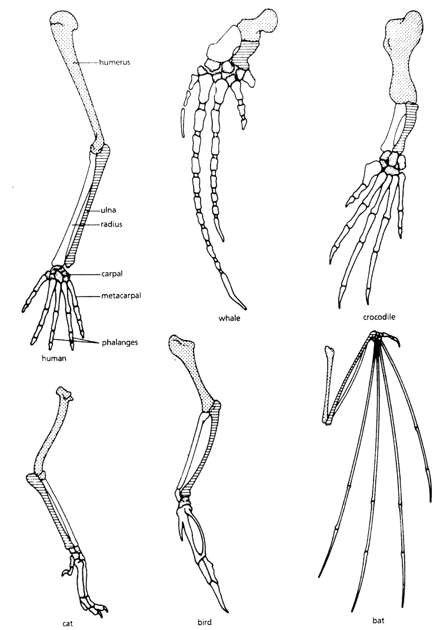
For each animal, indicate what type of movement each limb is responsible for.

Animal | Primary Functions
Human | Using tools, picking up and holding objects
Whale
Cat
Bat
Bird
Crocodile

Compare the skeletal structure of each limb to the human arm. Relate the differences you see in form to the differences in function.

Animal | Comparison to Human Arm in Form | Comparison to Human Arm in Function
Whale | Whale has a much shorter and thicker humerus, radius, and ulna. Much longer metacarpals. Thumb has been shortened to a stub. | The whale fin needs to be longer to help in movement through water. Thumbs are not necessary as the fins are not used for grasping.
Cat
Bat
Bird
Crocodile

Compare the anatomy of the butterfly and bird wing below.

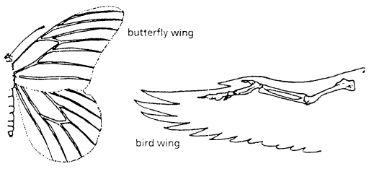

1. What is the function of each of these structures?

2. How are they different in form? Give specific differences.

Compare the overall body structure of the cave fish and the minnow below.

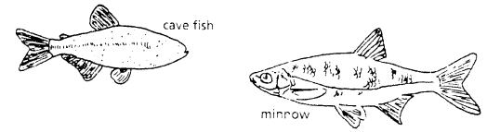

1. What is the biggest, most obvious difference between the body structure of these two fish?

2. Assume the two fish came from the same original ancestor. Why might the cave fish have evolved without eyesight?

3. What kind of sensory adaptation would you hypothesize the cave fish has to allow it to navigate in a cave, including catching and eating food?

You have now studied three different types of anatomical structures:

- Homologous structures show individual variations on a common anatomical theme. These are seen in organisms that are closely related.

1. Give an example of a homologous structure from this activity:

- Analogous structures have very different anatomies but similar functions. These are seen in organisms that are not necessarily closely related, but live in similar environments and have similar adaptations.

2. Give an example of an analogous structure from this activity:

- Vestigial structures are anatomical remnants that were important in the organism’s ancestors, but are no longer used in the same way.

3. Give an example of a vestigial structure from this activity:

4. Below are some vestigial structures found in humans. For each, hypothesize what its function may have been.

Structure | Possible function?
Wisdom teeth
Appendix
Muscles for moving the ear
Body hair
Little toe
Tailbone

5. How are vestigial structures an example of evidence of evolution?

Conclusion

1. Charles Darwin published his book On the Origin of Species in 1859. Of the different types of evidence that you have examined, which do you think he relied upon the most, and why?

2. Given the amount of research and evidence available on evolution, why is it classified as a theory?

Molecular Biology
Cytochrome c is a protein found in mitochondria. It is used in the study of evolutionary relationships because most animals have this protein. Cytochrome c is made of 104 amino acids joined together.
Below is a list of the amino acids in part of a cytochrome protein molecule for 9 different animals. Any sequences exactly the same for all animals have been skipped.

For each non-human animal, take a highlighter and mark any amino acids that are different than the human sequence. When you finish, record how many differences you found in the table on the next page.

 | 42 | 43 | 44 | 46 | 47 | 49 | 50 | 53 | 54 | 55 | 56 | 57
Human | Q | A | P | Y | S | T | A | K | N | K | G | I
Chicken | Q | A | E | F | S | T | D | K | N | K | G | I
Horse | Q | A | P | F | S | T | D | K | N | K | G | I
Tuna | Q | A | E | F | S | T | D | K | S | K | G | I
Frog | Q | A | A | F | S | T | D | K | N | K | G | I
Shark | Q | A | Q | F | S | T | D | K | S | K | G | I
Turtle | Q | A | E | F | S | T | E | K | N | K | G | I
Monkey | Q | A | P | Y | S | T | A | K | N | K | G | I
Rabbit | Q | A | V | F | S | T | D | K | N | K | G | I

 | 58 | 60 | 61 | 62 | 63 | 64 | 65 | 66 | 100 | 101 | 102 | 103 | 104
Human | I | G | E | D | T | L | M | E | K | A | T | N | E
Chicken | T | G | E | D | T | L | M | E | D | A | T | S | K
Horse | T | K | E | E | T | L | M | E | K | A | T | N | E
Tuna | V | N | N | E | T | L | R | E | K | A | T | S | -
Frog | T | G | E | E | T | L | M | E | S | A | C | S | K
Shark | T | Q | Q | E | T | L | R | I | K | T | A | A | S
Turtle | T | G | E | E | T | L | M | E | D | A | T | S | K
Monkey | T | G | E | D | T | L | M | E | K | A | T | N | E
Rabbit | T | G | E | D | T | L | M | E | K | A | T | N | E

Animal | Number of Amino Acid Differences Compared to Human Cytochrome C | Animal | Number of Amino Acid Differences Compared to Human Cytochrome C
Horse |  | Shark
Chicken |  | Turtle
Tuna |  | Monkey
Frog |  | Rabbit

Molecular Biology – Summary Questions
1. Based on the Cytochrome C data, which organism is most closely related to humans?

2. Do any of the organisms have the same number of differences from human Cytochrome C? In situations like this, how would you decide which is more closely related to humans?

Conclusion

1. Charles Darwin published his book On the Origin of Species in 1859. Of the different types of evidence that you have examined, which do you think he relied upon the most, and why?

2. Given the amount of research and evidence available on evolution, why is it classified as a theory?

