Name _______________________ Date ________ Period _____ Score_____

Characteristics of Life

READ AND THEN ANSWER THE QUESTIONS.

Most people feel confident that they could identify a living thing from a nonliving thing, but sometimes it’s not so easy. Scientists have argued for centuries over the basic characteristics that separate life from non-life. Some of these arguments are still unresolved. Despite these arguments, there do seem to be some generally accepted characteristics common to all living things. Anything that possesses all these characteristics of life is known as an organism.

- The scientific term for a living thing is a(n) _____________________.

1. CONTAIN ONE OR MORE CELLS

Scientists know that all living things are organized. The smallest unit of organization of a living thing is the cell. A cell is a collection of living matter enclosed by a barrier known as the plasma membrane that separates it from its surroundings. Cells can perform all the functions we associate with life.
Cells are organized and contain specialized parts that perform particular functions. Cells are very different from each other. A single cell by itself can form an entire living organism. Organisms consisting of only a single cell are called unicellular. A bacterium or a protist like amoebas and paramecia are unicellular. However, most of the organisms you are familiar with, such as dogs and trees, are multicellular. Multicellular organisms contain hundreds, thousands, even trillions of cells or more. Multicellular organisms may have their cells organized into tissues, organs, and systems. Whether it is unicellular or multicellular, all structures and functions of an organism come together to form an orderly living system.
Functional cells are not found in nonliving matter. Structures that contain dead cells or pieces of cells are considered dead. For example, wood or cork cut from a tree is made up largely of cell walls. The cells are no longer functional.

- All living things are ___________________.
- What is the simplest level at which life may exist?

- Are all cells alike?
- All cells perform various jobs or ________________.
- What surrounds a cell and separates it from its environment?
- What is the difference between unicellular and multicellular organisms?

- Give an example of a multicellular organism and an example of a unicellular organism.

- Multicellular organisms can be organized into what other levels?

- Circle which of the following would be made of cells. Place a box around the ones which only show cell walls.

Cork Sponge Wood Plastic Tree
- Examine these 2 organisms. Which one is unicellular and which is multicellular (label each)?
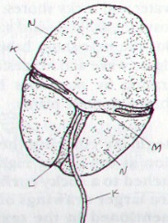
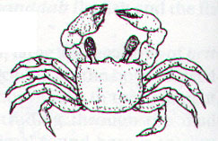

POND ORGANISM CRAB
(Under a microscope)
_______________ _______________

2. REPRODUCTION

Perhaps the most obvious of all the characteristics of life is reproduction, the production of offspring. Organisms don’t live forever. For life to continue, organisms must replace themselves. Reproduction is not essential for the survival of an individual organism. However, it is essential for the continuation of an organism’s species. A species is a group of similar-looking organisms that can interbreed and produce fertile offspring. If individuals in a species never reproduced, it would mean an end to that species’ existence on Earth.

- Define reproduction.

- Must EVERY member of a particular species (one kind of organism) be able to reproduce in order for the species to survive? Explain why or why not.
- What would happen if all individuals in a species were sterile (not able to have babies)?

- Reproduction is NOT essential for the survival of an individual ______________ but is essential for the survival of the _____________.
- What is meant by extinction?

There are two basic kinds of reproduction: sexual and asexual. Sexual reproduction requires that two cells (sperm and egg) unite to produce the first cell of the new organism. Organisms reproducing sexually do not always have “sex!” In many cases sperm and egg are released into the water where they meet. Most familiar organisms – from maple trees to birds and bees – reproduce sexually. In asexual reproduction, a single organism can reproduce without the aid of another. Sometimes these organisms can just divide themselves in two!

- Name and define the two basic kinds of reproduction.

- Identify which organisms are reproducing sexually and which are reproducing asexually.

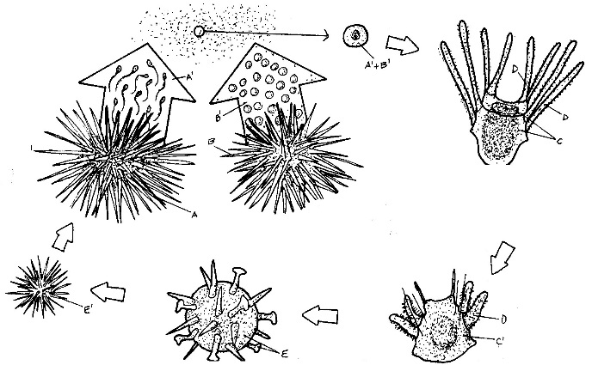
BACTERIA HYDRA SEA URCHIN
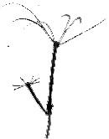
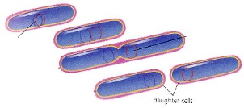

3. GROWTH AND DEVELOPMENT

Adults don’t always look like the babies of a species. All organisms begin their lives as single cells. Over time, these organisms grow and take on the characteristics of their species. Growth results in an increase in the amount of living material and the formation of new structures.
All organisms grow, and different parts of organisms may grow at different rates. Organisms made up of only one cell may change little during their lives, but they do grow. On the other hand, organisms made up of numerous cells go through many changes during their lifetimes. Think about some of the structural changes your body has already undergone in your short life. All of the changes that take place during the life of an organism are known as its development.

- How do all organisms begin life?
- What is the difference between growth and development?

- Do unicellular organisms GROW? Do unicellular organisms DEVELOP?

- Do multicellular organisms GROW? Do multicellular organisms DEVELOP?

- Identify which graphic BEST shows growth and which BEST shows development.

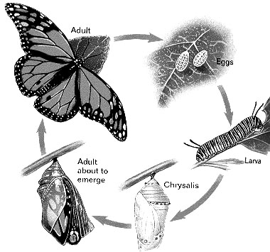
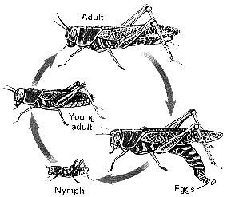

_________________________ ________________________

A snowball grows when you roll it over fresh snow! Why isn’t it a living thing? The growth of the snowball is not internal. It does not grow by producing more cells like organisms. It just adds on more material to the outside. Someone has to roll the snowball. It won’t grow bigger by just sitting there and it certainly cannot change liquid water or solid ice into new snow from which it can grow larger. This is one of the differences between growth of a living thing and growth of a nonliving thing.

- How is the growth of a living thing different from the growth of a nonliving thing?

4. OBTAIN AND USE ENERGY

Energy is the ability to make things change. Energy is important because it powers life processes. It provides organisms with the ability to maintain balance, grow, reproduce, and carry out other life functions. Some organisms obtain energy from the foods they eat or, in the case of plants and several other types of organisms, the foods that they produce. Organisms that get energy from the food they eat are called heterotrophs. Organisms that use energy from the sun to make their own food (which they then use for energy) are called autotrophs. The process is called photosynthesis.
As you’ll learn, energy doesn’t just flow through individual organisms; it also flows through communities of organisms, or ecosystems, and determines how organisms interact with each other and the environment.

- Define energy.

- Why is energy important to a living organism?

- What is the difference between an autotroph and a heterotroph?

- What is the name of the process that plants use to make their own food using energy from the sun?

- Identify each of the organisms below as either a heterotroph or an autotroph.
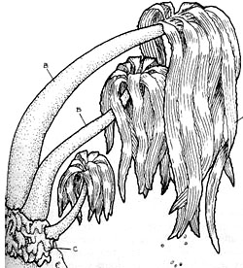
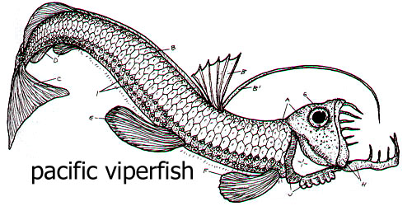

_________________________ ________________________

5. RESPOND TO THE ENVIRONMENT / MAINTAIN HOMEOSTASIS
Living things live in a constant connection with the environment, which includes the air, water, weather, temperature, any organisms in the area, and many other factors. These external environmental factors act as stimuli and can cause a response from living things. Organisms need to respond to the changes in order to stay alive and healthy. For example, if you go outside on a bright summer day, the sun may cause you to squint. Perhaps the bark of an approaching dog causes you to turn your head quickly. Just as you are constantly sensing and responding to changes in your environment, so are all other organisms. For example, a specialized leaf of the Venus’ flytrap senses the light footsteps of a soon-to-be-digested green bottle fly. The plant responded to this environmental stimulus by rapidly folding the leaf together.
An organism must respond to changes in the internal environment as well. Internal conditions include the level of water, nutrients, and minerals inside the body. It also refers to body temperature and hormone levels. Adjustments to internal changes help organisms maintain a stable internal environment. The regulation of an organism’s internal environment to maintain conditions suitable for life is called homeostasis. Or you can just think of it as keeping everything in BALANCE! For example, you have a “thermostat” in your brain that reacts whenever your body temperature varies slightly from 37°C (about 98.6°F). If this internal thermostat detects a slight rise in your body temperature on a hot day, your brain signals your skin to produce sweat. Sweating helps cool your body.
The ability of mammals and birds to regulate body temperature is just one example of homeostasis. Mechanisms of homeostasis enable organisms to regulate their internal environment, despite changes in their external environment.
- What are some environmental factors (stimuli) that organisms respond to?

- Organisms must also respond to ________________ factors in order to stay healthy & survive.
- What are two internal factors that organisms respond to?

- Give two examples from the reading of how living things respond to changes in their environment.

  - If light is applied to a human eye, how does it respond?

  - Describe homeostasis.

* * * * * * * * * * * * *
Identify the feature of life that is illustrated by each of the following statements. NOTE: You may use terms other than the characteristics of life!

- _______________________ “That boy shot up five inches in only one year.”
- _______________________ “Our cat had a litter of kittens yesterday.”
- _______________________ “My dog has become much less clumsy now that he is a year old.”
- _______________________ “Eat a good breakfast and you will be able to run longer.”
- _______________________ “When that car pulled in the driveway, my cat ran to hide under the porch.”
- __________________ “That owl’s night vision allows it to see the movement of
mice on even the darkest night.”
- _______________________ “Single-celled organisms live in the pond behind school.”
- _______________________ Your body normally maintains a temperature of 98.6^{O}F.
- _______________________ A giraffe uses its long neck to eat from the high branches of a tree.
- _______________________ is another name for “living thing.”
- Which of the following is a stimulus, which is a response?
  - the recess bell ringing in an elementary school
  - your mouth watering at the sight of food on a plate
  - a sudden drop in air temperature
  - a flu virus entering your body
  - getting “butterflies” in your stomach before giving a speech.
- Determine if each of the following describes a living or nonliving thing.
- rust eating a hole in a metal bucket _______________
- an apple on a tree ______________
- bacteria _______________
- lightning ______________
- a dinosaur fossil ______________
- a wasp __________

* * * * * * * * * * * *
Biology is:
=_________________________________________________________

Living Things are called:
=_______________________________________________

List Characteristics of ALL LIVING THINGS
- ___________________________________________________
- ___________________________________________________
- ___________________________________________________
- ___________________________________________________
- ___________________________________________________
- ___________________________________________________
- ___________________________________________________
- ___________________________________________________

Modern science has changed the way people understand their world. In the past, the people of many societies thought that mountains, rivers, and forests were “alive.’ In much the same way that animals and plants are alive. Today, most people recognize a difference between living and non-living things.

Fill out the table below. Explain HOW each shows the feature of life IF it does.

Feature of Life | Dog | Fast-moving stream
made of cells?
uses energy?
responds and adjusts to changes?
reproduces?
grows and develops?

Life is organized into many levels. The simplest level at which life exists is the cell. Life is also organized on nonliving levels (below the cell) and levels above the organism. Use your TEXTBOOK to arrange the following levels of organization in order for simplest to most complex --- ecosystem, atom, population, organ, molecule, biome, tissue, cell organelle, system, organism, community
LEVELS OF ORGANIZATION
NONLIVING
_______________
_______________
_______________
LIVING
____CELL_______
_______________
_______________
_______________
___ORGANISM___
_______________
_______________
_______________
_______________
Match each LEVEL to its MEANING.
(Use your textbook)
_____1. Atom/Molecule
_____2. Organ
_____3. Population
_____4. Biome
_____5. Cell
_____6. Organelle
_____7. Community
_____8. Ecosystem
_____9. Tissue
_____10. Organism
A. All living & nonliving things on earth
B. Smallest level at which life exists
C. a group of one kind of organism living in an area
D. group of similar cells working together
E. Several populations of organisms living together
F. a living thing that may be unicellular or multicellular
G. a group of similar tissues working together like the heart or lungs
H. all the living and nonliving things living in a similar environment such as a desert
I. parts of a cell such as the nucleus
J. smallest part of an element or compound

